**Case 4-Eur-Crete-Snake Goddess Ariadne Statue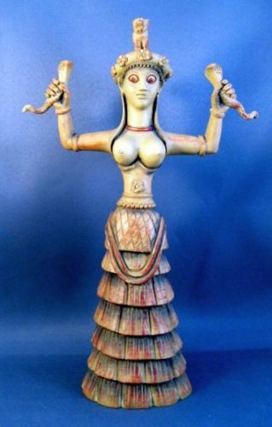Goddess Ariadne Statue** N5630 **9 inches high gypsumstone statue, handpainted.   
  
Antiqued stone colored gypsumstone.**

**[Candia Museum, Crete,1600-1500 BCE]**

**Antiqued stone colored gypsumstone. Here the Goddess is adorned with her Cobra and Panther headdress as she holds the snake of rebirth and regeneration.**

**Goddess of Ecstatic Trance.  
Her priestesses, bare-breasted, practiced ritual snake handling, ecstatic dancing, and prophetic trance. Priestess-queens ruled Crete, the last culture in recorded history to support equality. Her staring gaze denotes an oracular role of this Goddess who appears to be in a trance with her snake companions.**

**GREEK ARIADNE  
"The High Fruitful One," brings Rebirth**

**This lunar fertility goddess was known for her athletic prowess. Serpents, symbols of rebirth, were ritually handled by her priestesses, whose bare-breasted costumes suggest the sacred role of sexuality in the Minoan culture.**

**Serpent Goddess promotes trance and dream time. The energy exuded by the snakes of this Cretan maiden exemplify sexuality, regeneration, and the mysterious otherworld of spirit journeying. Note her staring gaze and enigmatic inward smile, and if you choose, invite these "otherworldly" characteristics into your own meditations.**

**THE DELICATE SERPENT GODDESS (of Knossos) was discovered in the underground repository of the Second Palace of Knossos (1600 BCE] and was worshiped in Crete as early as 6000 BCE. She depicts the benevolence and sacred power of the Life Force, holding high the two serpents of immortality. The tiny panther or lion cub on her headdress may connect the goddess to the fertility rites of the wine god Dionysos or denote an altered state of consciousness.**

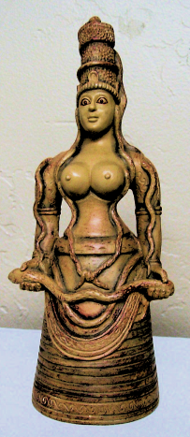**Snake Goddess Ariadne Statue  
Goddess Ariadne Statue  
9 inches high gypsumstone statue, handpainted.   
  
Antiqued stone colored gypsumstone.**

**[Candia Museum, Crete,1600-1500 BCE]**

**Antiqued stone colored gypsumstone. Here the Goddess is adorned with her Cobra and Panther headdress as she holds the snake of rebirth and regeneration.**

**Goddess of Ecstatic Trance.  
Her priestesses, bare-breasted, practiced ritual snake handling, ecstatic dancing, and prophetic trance. Priestess-queens ruled Crete, the last culture in recorded history to support equality. Her staring gaze denotes an oracular role of this Goddess who appears to be in a trance with her snake companions.**

**GREEK ARIADNE  
"The High Fruitful One," brings Rebirth**

**This lunar fertility goddess was known for her athletic prowess. Serpents, symbols of rebirth, were ritually handled by her priestesses, whose bare-breasted costumes suggest the sacred role of sexuality in the Minoan culture.**

**Serpent Goddess promotes trance and dream time. The energy exuded by the snakes of this Cretan maiden exemplify sexuality, regeneration, and the mysterious otherworld of spirit journeying. Note her staring gaze and enigmatic inward smile, and if you choose, invite these "otherworldly" characteristics into your own meditations.**

**THE DELICATE SERPENT GODDESS (of Knossos) was discovered in the underground repository of the Second Palace of Knossos (1600 BCE] and was worshiped in Crete as early as 6000 BCE. She depicts the benevolence and sacred power of the Life Force, holding high the two serpents of immortality. The tiny panther or lion cub on her headdress may connect the goddess to the fertility rites of the wine god Dionysos or denote an altered state of consciousness.**

­

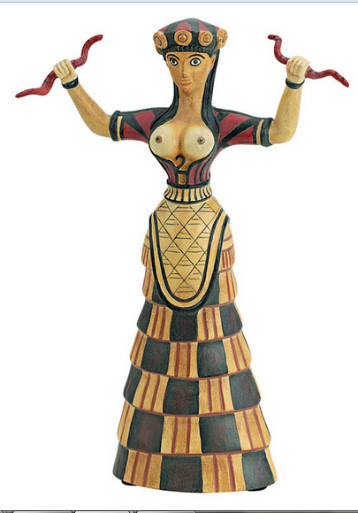Cretan Minoan Snake Goddess of Knossos Statue Sculpture Replica Reproduction

Made of cast stone

Dimensions: 12"High (30.5 cm)

Weight: 3 lbs (1.4 k

(1.4 kg)

Item No. 5082

Herakleion Museum, Crete, Greece

Period: pre-Hellenic (2800 - 800 B.C.)

Cretan Minoan Snake Goddess of Knossos Statue Sculpture Item No. 5082 Reproduced after the original from the Herakleion Museum, Crete, Greece. 1600 B.C. This figurine represents an agricultural fertility Goddess or her Priestess. The original was found in a storage room in the Palace of Knossos, Crete. She is a votive offering and not a cult figure and therefore, probably represents a Priestess who is perhaps a princess of the palace. Although she is dressed in the garb of her deity, a Cretan Earth Mother, she is a personification of Earth from which all life springs and returns. She carries the snakes, symbols of death and rebirth. Crouching on her crown is a lion cub, usually associated with royal houses. In her crown are poppy pods, indicating the use of opium in her worship.

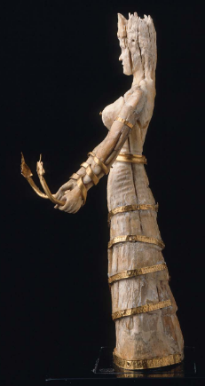 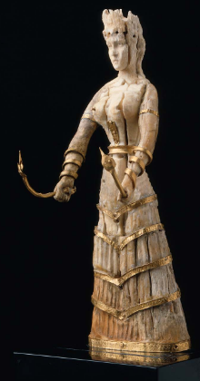 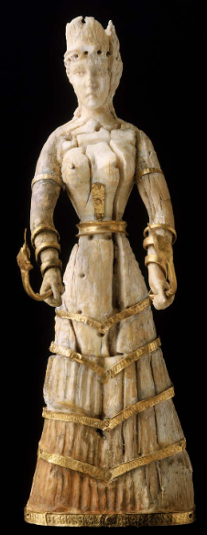

Snake goddess ivory statuette, Minoan Bronze Age, 1600-1500 BCE

**Formal Label:** Snake goddess ivory statuette, Minoan Bronze Age, 1600-1500 BCE

**Accession Number:** NB91.P25

**Date or Time Horizon:** Minoan Bronze Age, 1600-1500 BCE

**Geographical Area:** Knossos, Crete

**Cultural Affiliation:** Minoan Bronze Age, 1600-1500 BCE

**Medium:** Gold, ivory

**Dimensions:** 16.1 cm (6 5/16 in.)

**Weight:**

**Provenance:** BMFA, 14.863

**Condition: Museum**

**Discussion:**

The elaborate headdress, or crown,

is of a type which appears to be without parallels in Minoan art.

It curves up at the front, back, and sides in semi-circular form,

and a small cyhndrical piece,

now much damaged, rises in

the centre. Each of the four

semi-circular divisions is

pierced near the top for the

attachment of a rosette or

some other ornament, prob-

ably of gold, and the one at

the front is further decorated

with a small raised disk, or

boss. A gold band encircled

the crown near the bottom, as

is proved by a nail hole at the

back. The hair over the forehead is treated as a slightly raised

mass in which is a row of seven drilled holes, about 6 mm. deep,

with shallow circular depressions between them. On the analogy

of the well known ivory heads from Knossos (Fig. 1, reproduced

from B.SA, VIII, p. 72, figs. 37, 38), it may be confidently as-

serted that these holes held small gold curls, and that they did not

serve for the attachment of a gold wreath, or diadem, as Gard-

ner has suggested. Numerous frescoes show that such loose

tendrils of hair floating about the forehead were a characteristic

**References:**

Caskey, Lacey Davis. 1915. [**A Chryselephantine statuette of the Cretan snake-goddess in the Museum of Fine Arts, Boston**](http://www.worldcat.org/title/chryselephantine-statuette-of-the-cretan-snake-goddess-in-the-museum-of-fine-arts-boston/oclc/83217450&referer=brief_results) . Museum of Fine Arts, a reprint of the article in the American Journal of Archaeology, 1914.